**Practical 2**

**Implement and demonstrate the use of following in solidity**

**Variables**

testVariable

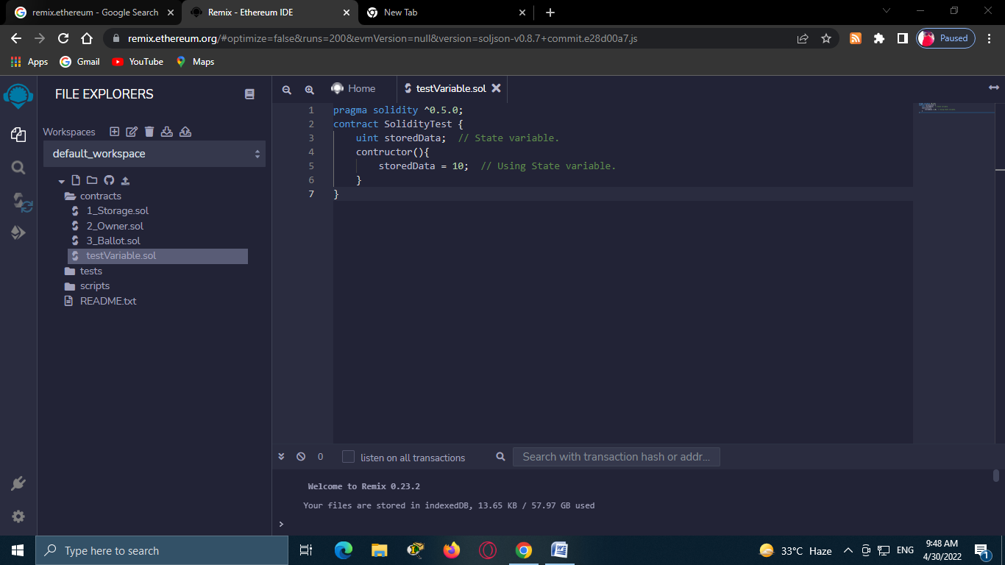

testVariable2

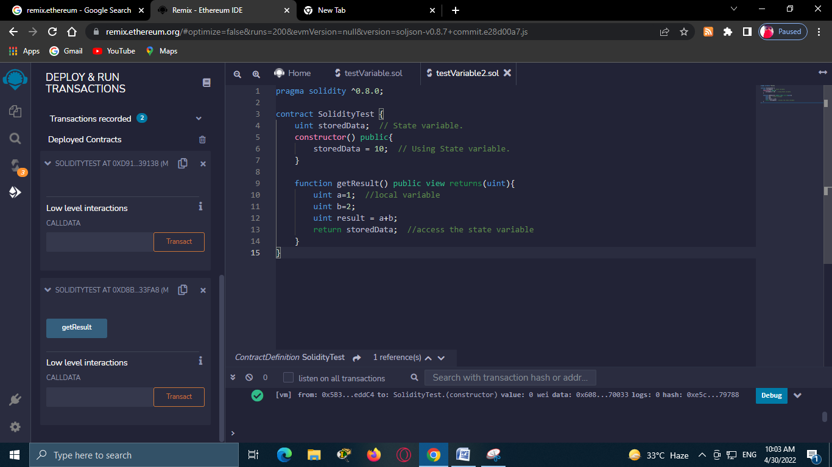

Code

pragma solidity ^0.8.0;

contract SolidityTest {

    uint storedData;  // State variable.

    constructor() public{

        storedData = 10;  // Using State variable.

    }

    function getResult() public view returns(uint){

        uint a=1;  //local variable

        uint b=2;

        uint result = a+b;

        return storedData;  //access the state variable

    }

}

Steps to deploy

Click to the arrow symbol and check the name to the contract.

And then click on deploy.

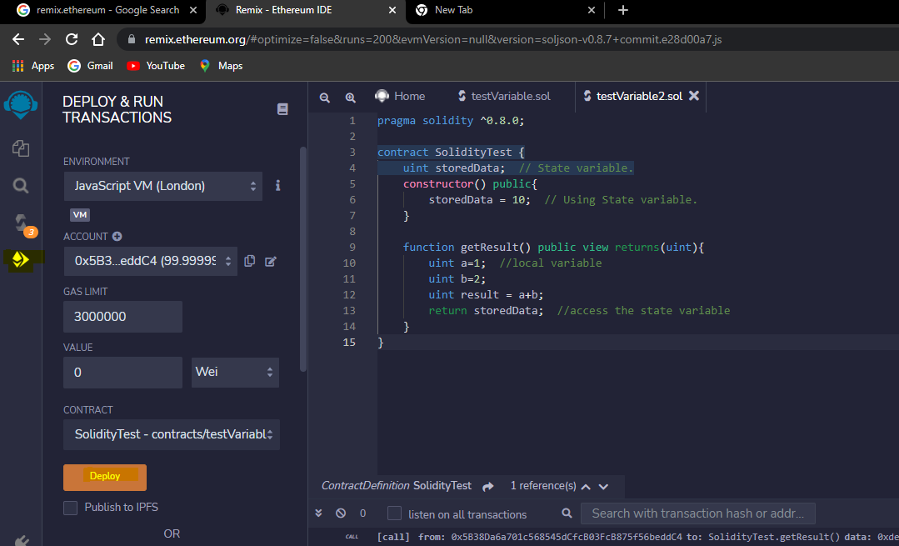

Output:

Scroll down the left hand side. Below the deploy button, you will get the button getResult. Click on it and you will the output of your program.

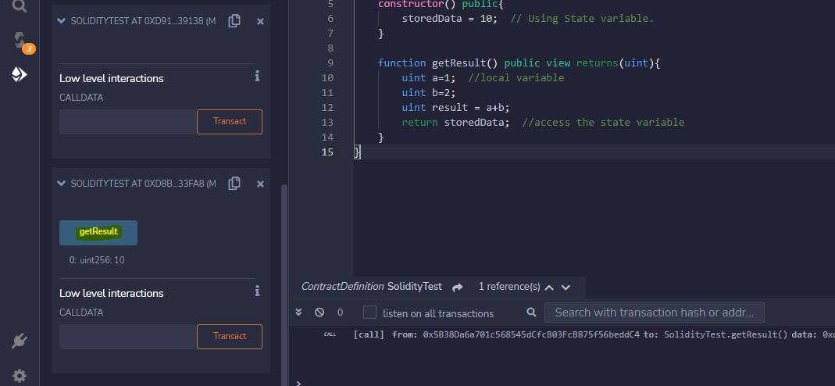

Note : Every time you make the changes in the program, you have to first deploy and then check for the output.

Variable Test : State variable

varTest

pragma solidity ^0.8.0;

contract VarTest {

    uint public state_var;  // State variable.

    constructor() public{

        state_var = 20;  // Using State variable.

    }

}

Deploy :

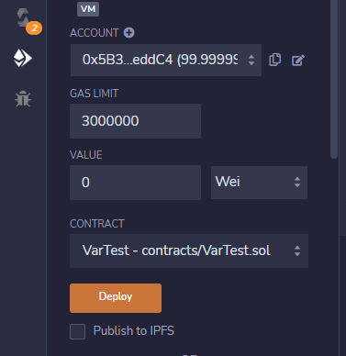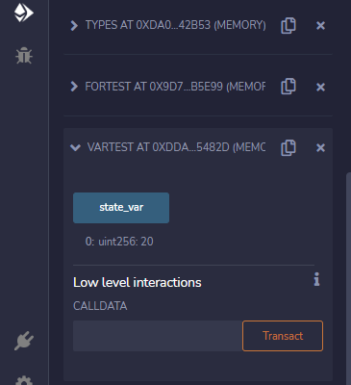

Output :



VarTest2 : Local variable

pragma solidity ^0.8.0;

contract localVarTest {

    uint storedData;  // State variable.

    constructor() public{

        storedData = 10;  // Using State variable.

    }

    function getResult() public view returns(uint){

        uint a=1;  //local variable

        uint b=2;

        uint result = a+b;

        return result;  //access the local variable

    }

}

Deploy:

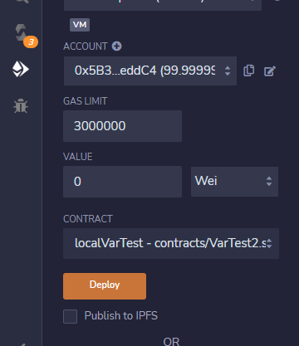

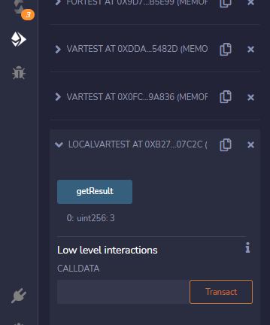

Output:



Variable test : Global variable

pragma solidity ^0.8.0;

contract globalVarTest {

    address public admin;

    constructor() public{

        admin = msg.sender;

    }

}

Deploy

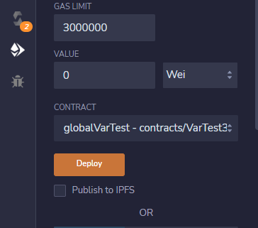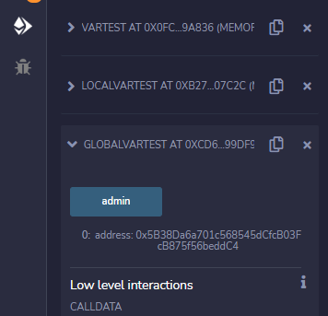

Output:

